Heaven Hearth

Welcome to Heaven Hearth, where every visit feels like a journey of culinary delight. Our passion for creating memorable dining experiences drives everything we do, from the carefully crafted menu to the warm ambiance that greets you at our doorstep.

At Heaven Hearth we believe in celebrating the art of food. Our chefs expertly blend flavors and ingredients to create dishes that tantalize the taste buds and leave you craving more. Whether you're joining us for breakfast, lunch, or dinner, each bite is a symphony of flavors that tells a story of craftsmanship and creativity.

But it's not just about the food. It's about the atmosphere, the camaraderie, and the sense of belonging that you'll find here. Our restaurant is more than just a place to eat – it's a community where friends and family come together to create lasting memories.

THE PAGES: (the letters show the content of the page in order.)

1. Home page:

Our homepage is designed to welcome you to HeavenHearth with open arms. It features our logo, a photo of our location, both interior, and exterior shots of the restaurant, as well as a schedule table for your convenience. We aim to provide a warm and inviting atmosphere right from the start.

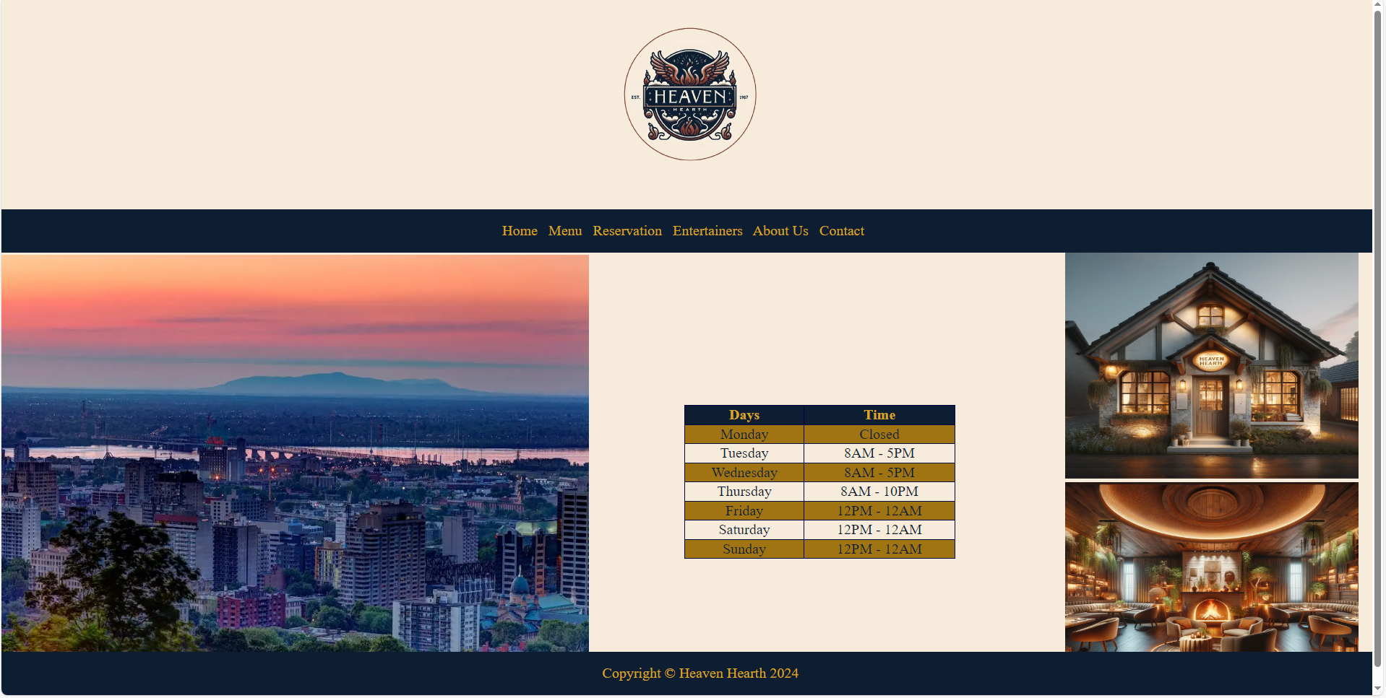

On our menu page, we've curated a culinary journey just for you:

a. Specials of the Week: Indulge in our chef's latest creations, featuring seasonal delights and unique flavors that will tantalize your taste buds.

b. Breakfast Menu: Start your day off right with a selection of hearty breakfast options, from fluffy pancakes to savory omelets, guaranteed to fuel your morning.

c. Diner Menu: Dive into classic diner favorites, from juicy burgers to comforting sandwiches and salads, perfect for a satisfying lunch or casual dinner.

d. Supper Menu: As the day transitions into evening, savor our enticing supper menu, showcasing mouthwatering dishes crafted with care and attention to detail.

e. Drinks: Whether it's a refreshing morning pick-me-up or a relaxing evening cocktail, explore our array of beverages available both before 5 pm and after, including coffee, tea, juices, wines, and cocktails.

f. Kids Menu (Ages 1-12): Treat the little ones to their favorites with our specially curated kids' menu, featuring delicious and nutritious options that are sure to please even the pickiest eaters.

g. Desserts: Indulge your sweet tooth with our delectable dessert selection, featuring irresistible treats ranging from decadent cakes to creamy puddings, the perfect way to end your meal on a sweet note.

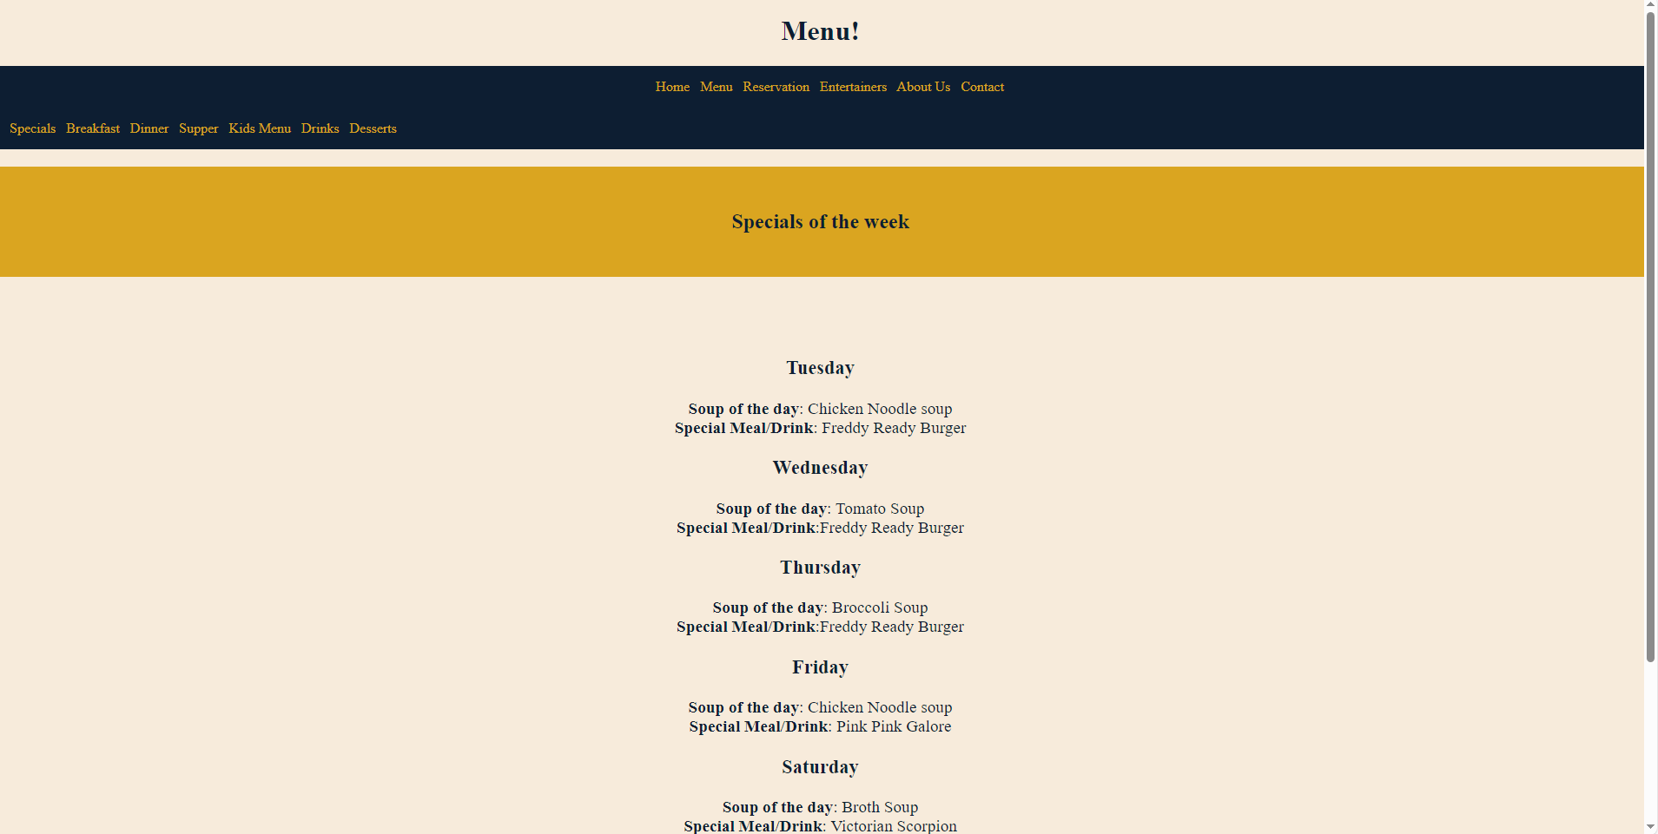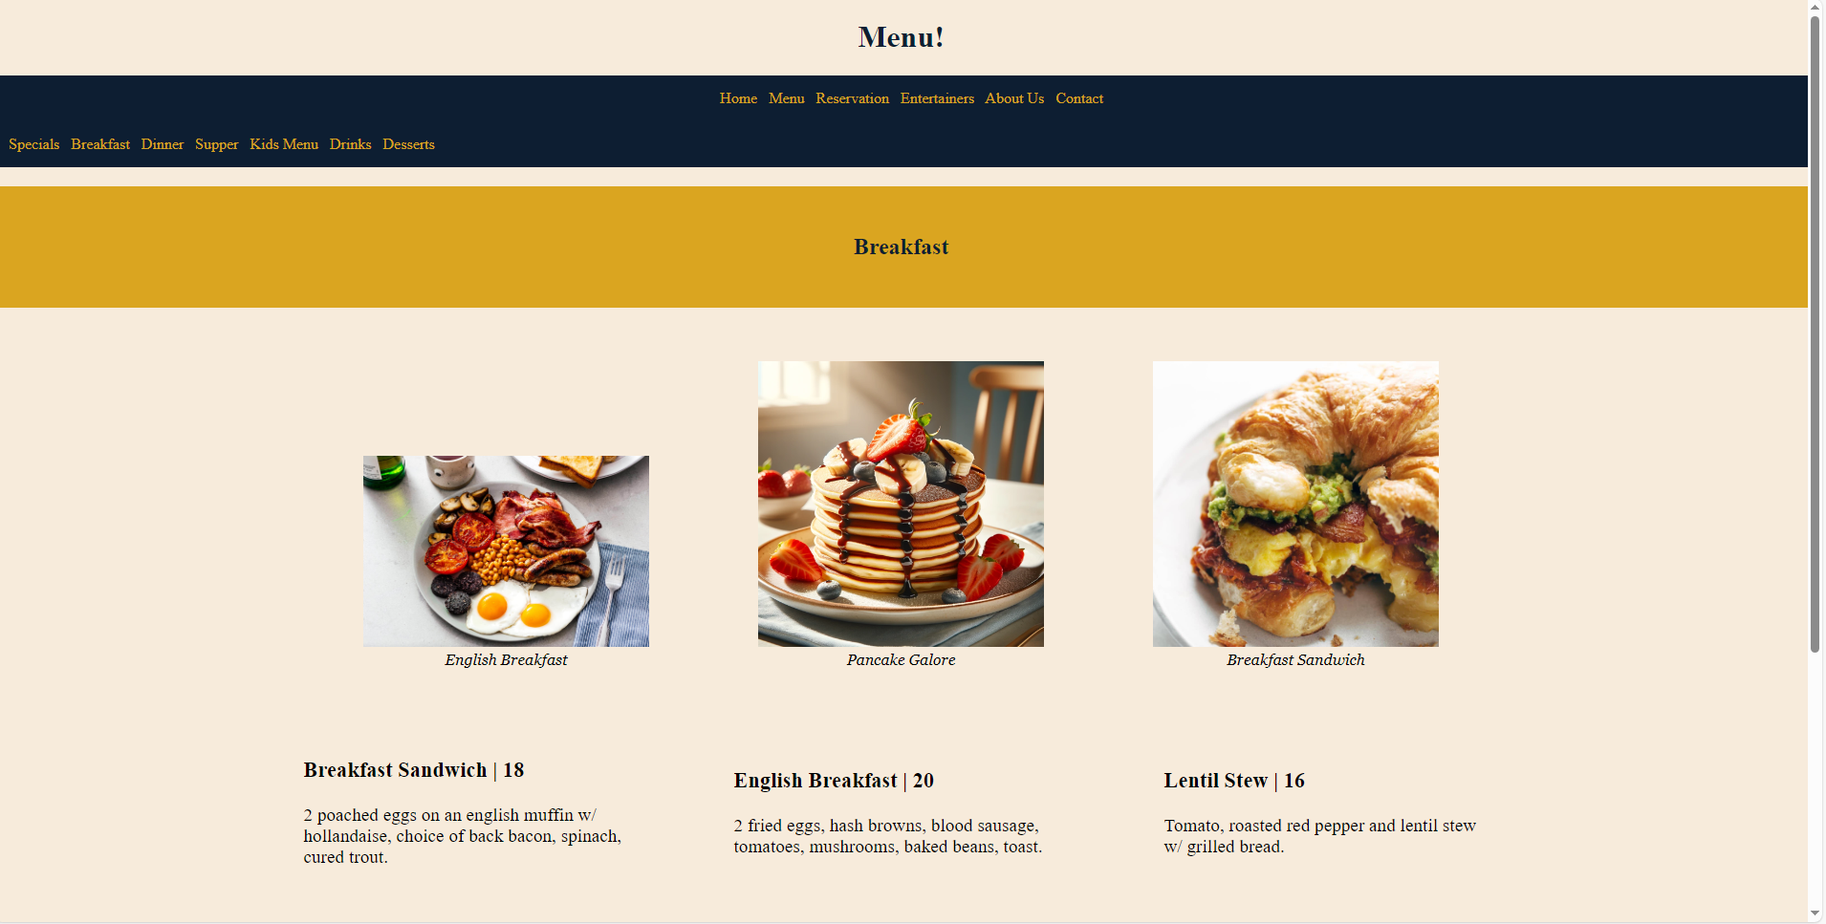

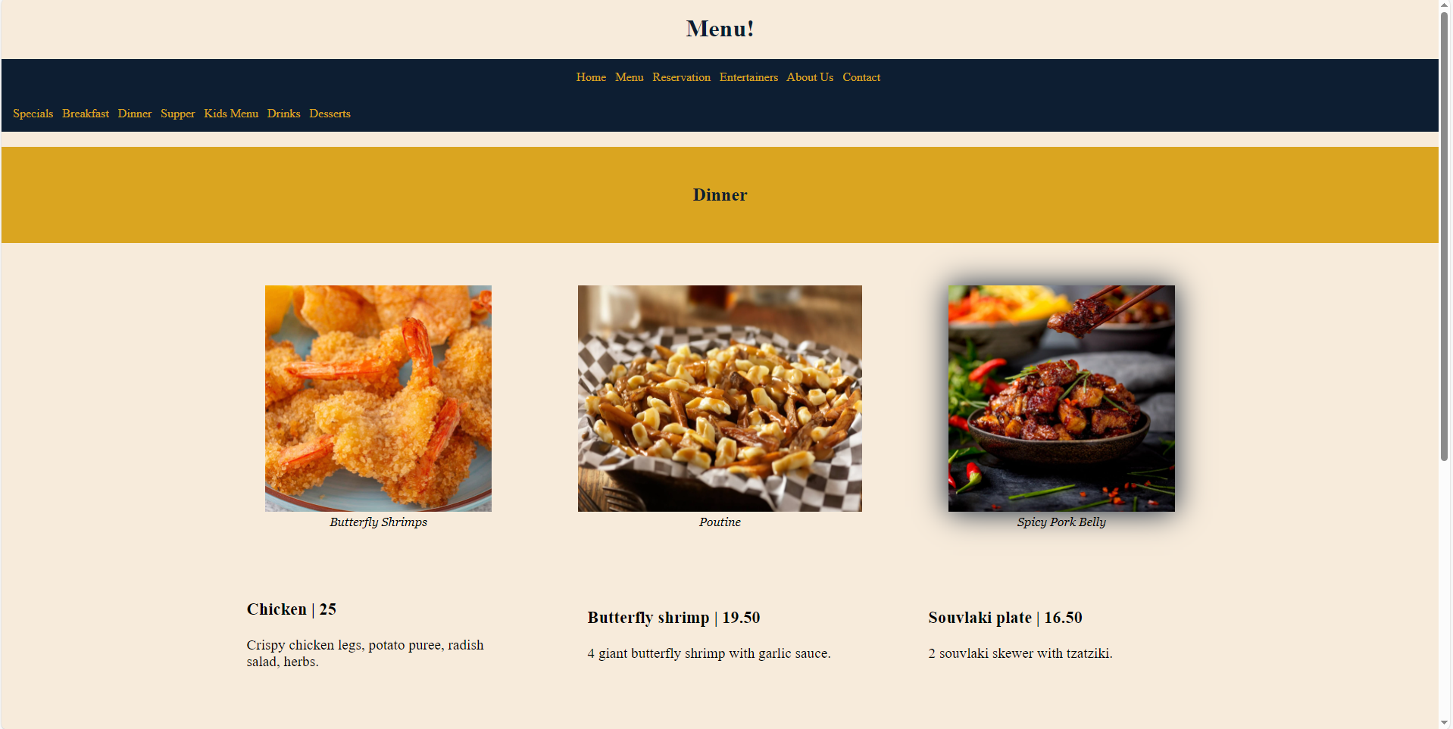

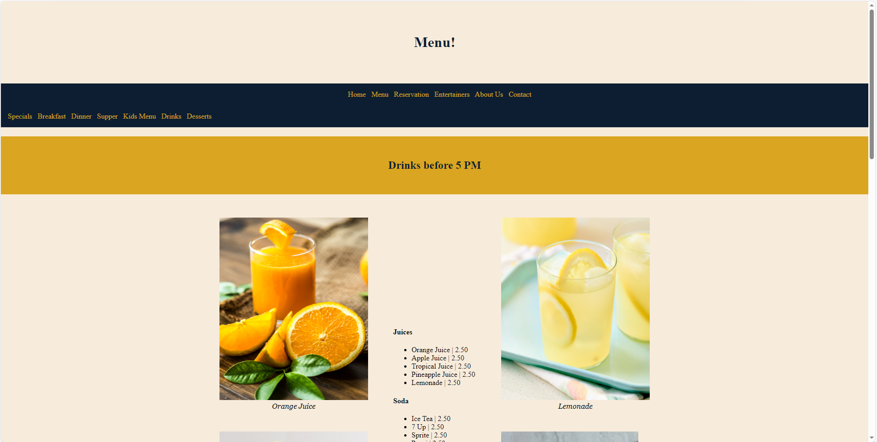

For our reservation page, we've streamlined the process to make booking a table as easy as possible:

a. Reservation Form: Simply fill out the form with details such as the number of people in your party, preferred type of seating, desired time and date, and any special occasion you're celebrating, such as a birthday.

b. Price Calculation: Using JavaScript, we dynamically calculate the price of your reservation based on the information provided. Factors such as the number of people, type of seating, and special requests are taken into account to provide you with an accurate price estimate.

With our user-friendly reservation system, securing your spot at [Restaurant Name] has never been simpler. We look forward to welcoming you for a memorable dining experience.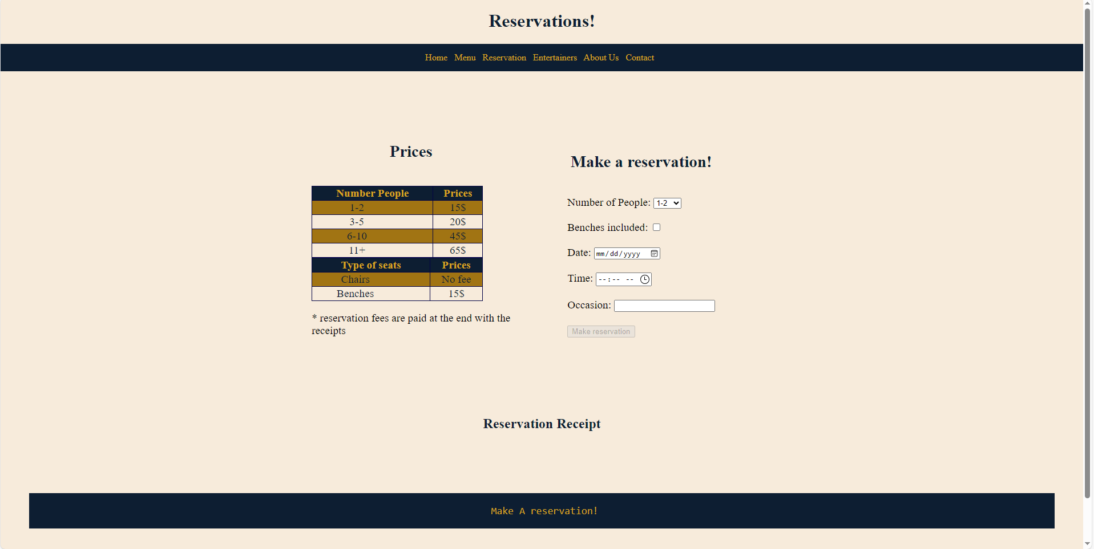

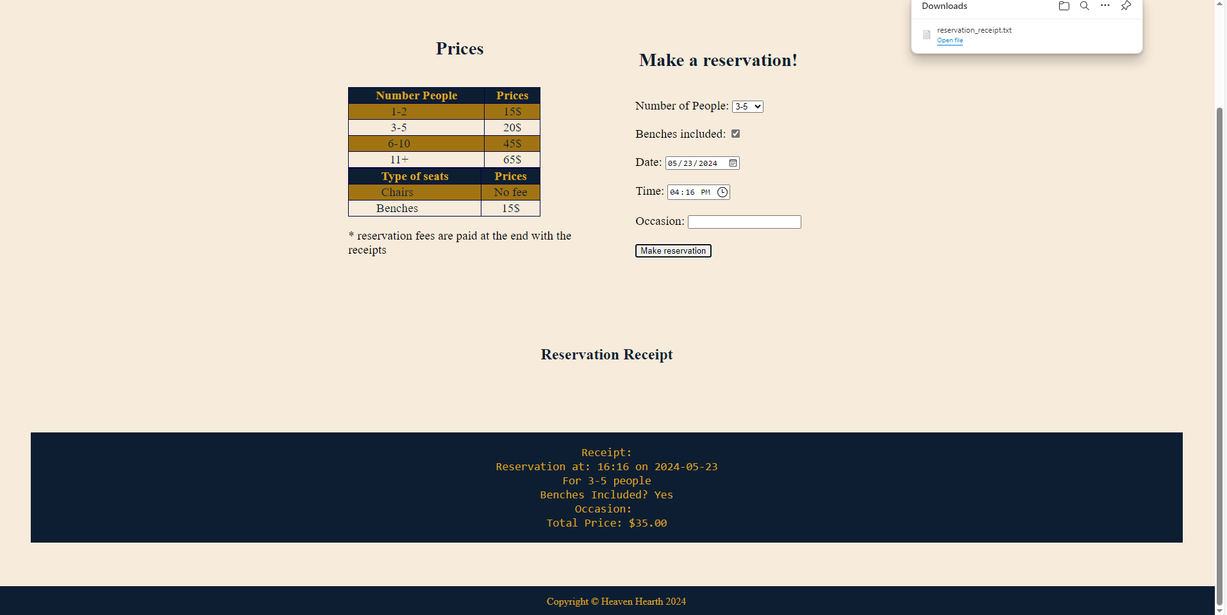

Explore our entertainer schedule and get to know the talented individuals who bring joy to our guests:

- Freddy Fazbear:

- Schedule: Tuesday, Wednesday, Thursday 8:00 AM - 5:00 PM and 8:00AM – 10 PM

- Description: Freddy Fazbear is a lively animatronic performer known for his energetic dance routines and interactive performances. Join him on select evenings for a family-friendly experience filled with music and fun.

- Jigglypuff:

- Schedule: Friday, 12:00 PM – 12:00 AM

- Description: Jigglypuff, the adorable Pokémon with a mesmerizing singing voice, takes the stage on Fridays to serenade guests with enchanting melodies. Sit back, relax, and let Jigglypuff's soothing tunes create a magical atmosphere for all ages to enjoy.

- Kass:

- Schedule: Wednesdays, 12:00 PM – 12:00 AM

- Description: Kass, the wandering minstrel from Hyrule, graces our establishment every Wednesday evening with his enchanting melodies. With his trusty accordion in hand, Kass transports guests to distant lands with his soul-stirring music. Join us for a captivating performance that will leave you feeling uplifted and inspired.

Immerse yourself in the world of entertainment at Heaven Hearth, where our talented performers are sure to leave you smiling.

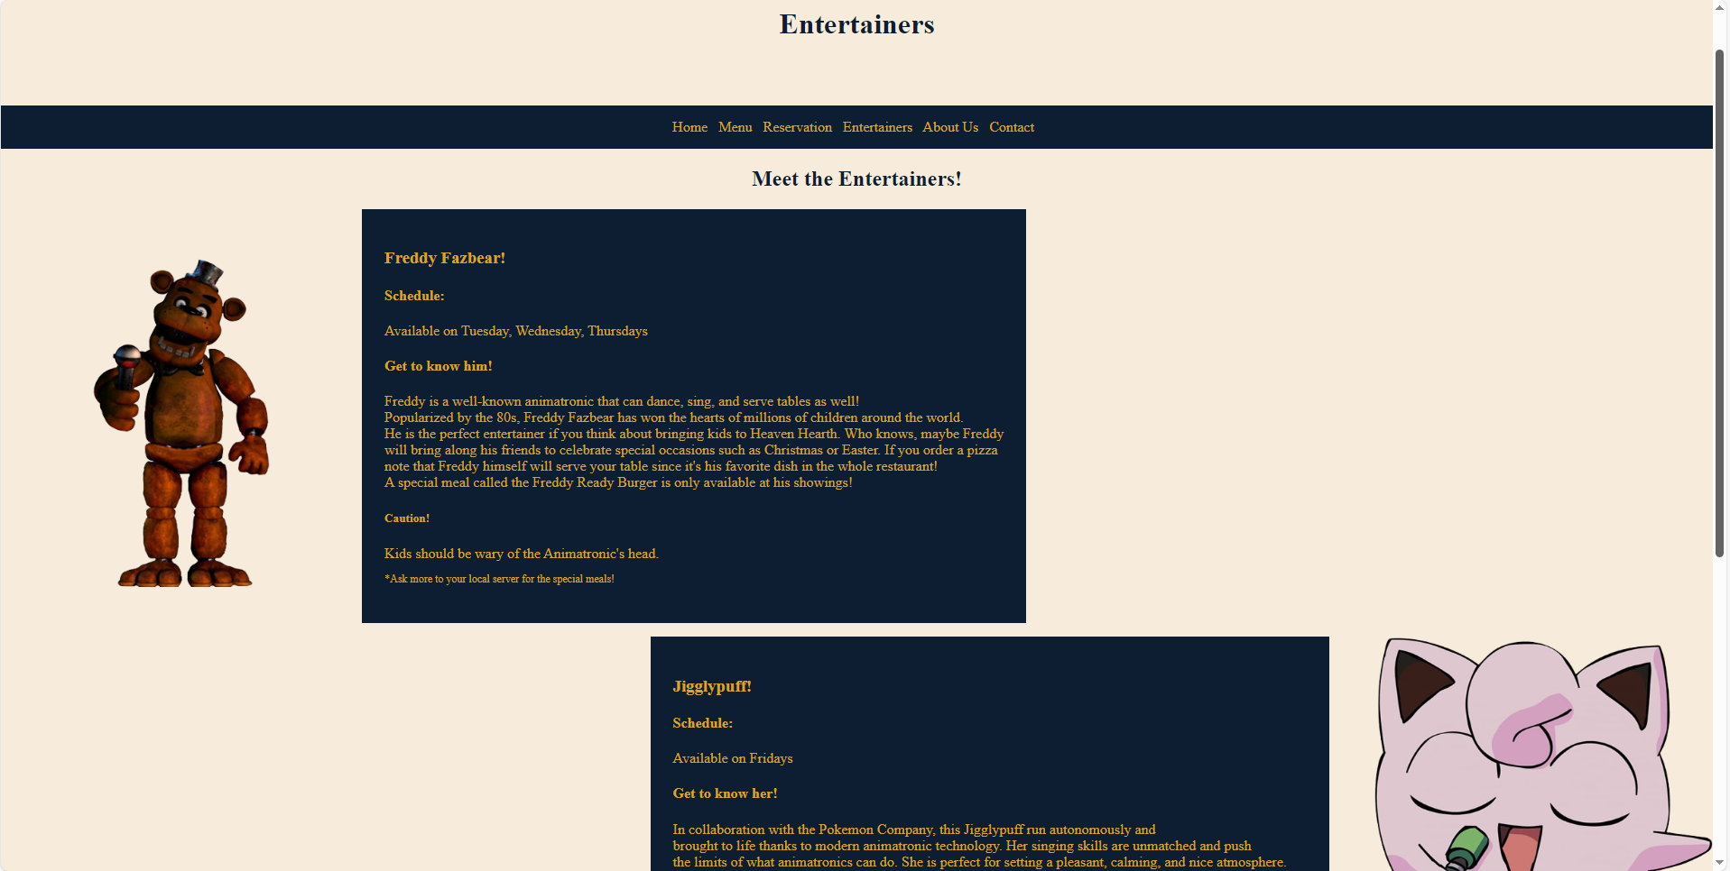

Contact us through various channels to reach out or stay connected:

- Email: HeavenHearth@gmail.com

- Phone: 438-501-0341

- Address: 150 Saint-Catherine St W, Montreal, Quebec, H2X 3Y2

- Instagram: @HeavenHearth

Whether you have inquiries, feedback, or simply want to follow our latest updates, we're here to hear from you. Feel free to reach out through your preferred platform.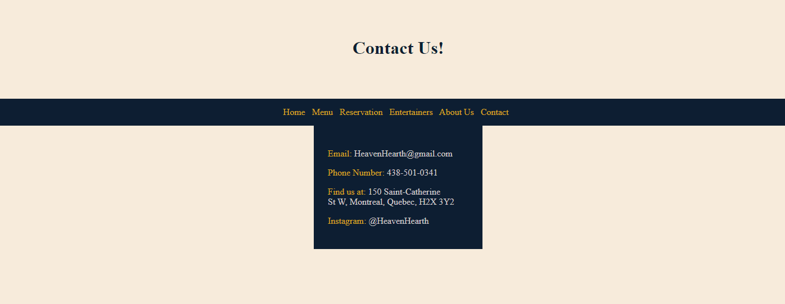

As you explore our About Us page, we invite you to watch our restaurant ad, a visual showcase of everything we stand for. From our logo to the smiling faces of our staff, every frame is a testament to our commitment to excellence.

Thank you for choosing Heaven Hearth. We look forward to serving you soon.

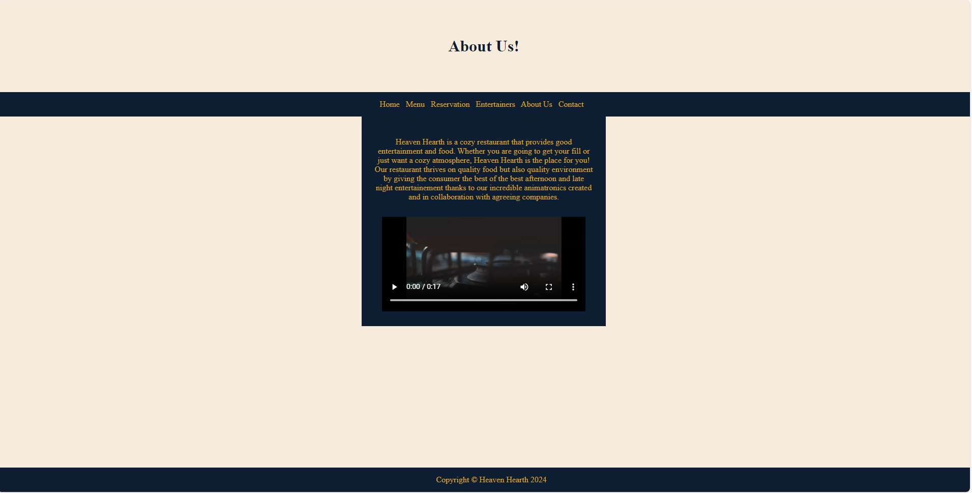

Color Schemed used for our website: white and gold and blue

Implementation:

* All pages are going to use CSS and HTML.
* For the reservation page, it will use JavaScript and the data of this reservation will be stored in a text file while JSON will be used to store the receipt as well in the local storage.
* All pages also support multiple types of screens for easy accessibility

Layouts:

A lot of my containers uses a display type flex which means they usually adapt to the screen getting smaller and such. The layout responsiveness will be based on making images or containers smaller if their sizes are bigger than the screen. We also change the nature of the flex display to grid to make It easier to organize.